Shefali Emmanuel

Advanced Algorithms Midterm 2

Due: November 20, 2018



Source: Longest Common Subsequence packet given in class

Answer: “algor”

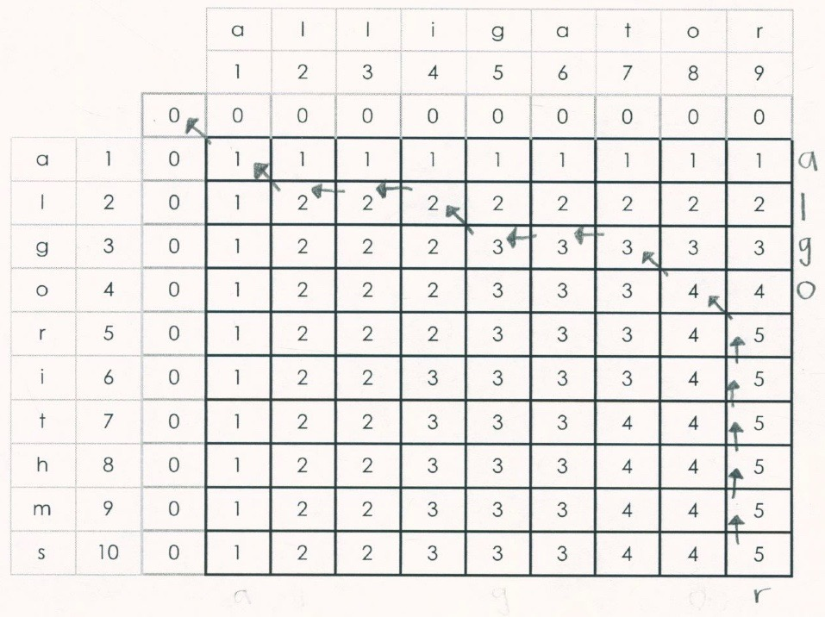

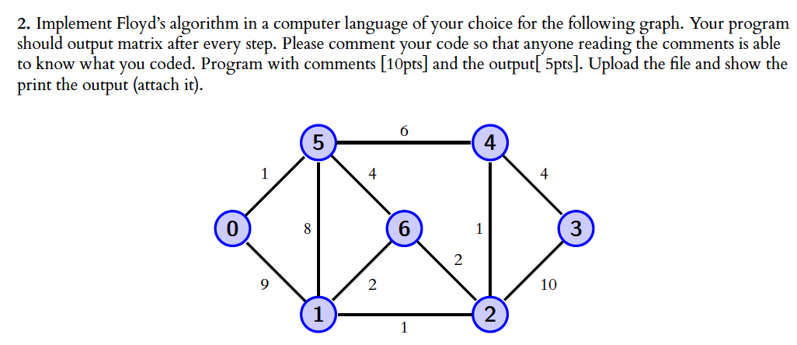

Sources:

<https://www.youtube.com/watch?v=B06q2yjr-Cc>

Chapter 8.4 in the book!

<https://www.geeksforgeeks.org/floyd-warshall-algorithm-dp-16/>

#2 Answer by hand:

|  |  |  |  |  |  |  |  |
| --- | --- | --- | --- | --- | --- | --- | --- |
| Initial State Distance Table | 0 | 1 | 2 | 3 | 4 | 5 | 6 |
| 0 | 0 | 7 | ∞ | ∞ | ∞ | 1 | ∞ |
| 1 | 7 | 0 | 1 | ∞ | ∞ | 8 | 2 |
| 2 | ∞ | 1 | 0 | 10 | 1 | ∞ | 2 |
| 3 | ∞ | ∞ | 10 | 0 | 4 | ∞ | ∞ |
| 4 | ∞ | ∞ | 1 | 4 | 0 | 6 | ∞ |
| 5 | 1 | 8 | ∞ | ∞ | 6 | 0 | 4 |
| 6 | ∞ | 2 | 2 | ∞ | ∞ | 4 | 0 |

|  |  |  |  |  |  |  |  |
| --- | --- | --- | --- | --- | --- | --- | --- |
| 1st Iteration of Change in Distance Table | 0 | 1 | 2 | 3 | 4 | 5 | 6 |
| 0 | 0 | 7 | ∞ | ∞ | ∞ | 1 | ∞ |
| 1 | 7 | 0 | 1 | ∞ | ∞ | 8 | 2 |
| 2 | ∞ | 1 | 0 | **5** | 1 | ∞ | 2 |
| 3 | ∞ | ∞ | **5** | 0 | 4 | ∞ | ∞ |
| 4 | ∞ | ∞ | 1 | 4 | 0 | 6 | ∞ |
| 5 | 1 | 8 | ∞ | ∞ | 6 | 0 | 4 |
| 6 | ∞ | 2 | 2 | ∞ | ∞ | 4 | 0 |

|  |  |  |  |  |  |  |  |
| --- | --- | --- | --- | --- | --- | --- | --- |
| 2nd Iteration of Change in Distance Table | 0 | 1 | 2 | 3 | 4 | 5 | 6 |
| 0 | 0 | 7 | ∞ | ∞ | ∞ | 1 | ∞ |
| 1 | 7 | 0 | 1 | ∞ | ∞ | **6** | 2 |
| 2 | ∞ | 1 | 0 | **5** | 1 | ∞ | 2 |
| 3 | ∞ | ∞ | **5** | 0 | 4 | ∞ | ∞ |
| 4 | ∞ | ∞ | 1 | 4 | 0 | 6 | ∞ |
| 5 | 1 | **6** | ∞ | ∞ | 6 | 0 | 4 |
| 6 | ∞ | 2 | 2 | ∞ | ∞ | 4 | 0 |

|  |  |  |  |  |  |  |  |
| --- | --- | --- | --- | --- | --- | --- | --- |
| 3rd Iteration of Change in Distance Table by going through each other | 0 | 1 | 2 | 3 | 4 | 5 | 6 |
| 0 | 0 | 7 | **7** | **11** | **7** | 1 | **5** |
| 1 | 7 | 0 | 1 | **6** | **2** | **6** | 2 |
| 2 | **7** | 1 | 0 | **5** | 1 | **6** | 2 |
| 3 | **11** | **6** | **5** | 0 | 4 | **10** | **7** |
| 4 | **7** | **2** | 1 | 4 | 0 | 6 | **3** |
| 5 | 1 | **6** | **6** | **10** | 6 | 0 | 4 |
| 6 | **5** | 2 | 2 | **7** | **3** | 4 | 0 |

#2 Answer by code:

In additional files on OAKS



Sources:

<https://www.geeksforgeeks.org/boyer-moore-algorithm-for-pattern-searching/>

<https://www.geeksforgeeks.org/boyer-moore-algorithm-good-suffix-heuristic/>

<https://www.cs.tufts.edu/comp/150GEN/classpages/BoyerMoore.html>

<https://www.sanfoundry.com/java-program-boyer-moore-algorithm/>

<https://www.youtube.com/watch?v=lkL6RkQvpMM>

Example in Code:

Text = “SHEFSH3FALISHEFAILSHEFAIILSHAFALI”

Pattern = ”AIL”

|  |  |  |  |  |  |  |  |  |  |  |  |  |  |  |  |  |  |  |  |  |  |  |  |  |  |  |  |  |  |  |  |  |
| --- | --- | --- | --- | --- | --- | --- | --- | --- | --- | --- | --- | --- | --- | --- | --- | --- | --- | --- | --- | --- | --- | --- | --- | --- | --- | --- | --- | --- | --- | --- | --- | --- |
| 0 | 1 | 2 | 3 | 4 | 5 | 6 | 7 | 8 | 9 | 10 | 11 | 12 | 13 | 14 | 15 | 16 | 17 | 18 | 19 | 20 | 21 | 22 | 23 | 24 | 25 | 26 | 27 | 28 | 29 | 30 | 31 | 32 |
| S | H | E | F | S | H | 3 | F | A | L | I | S | H | E | F | A | I | L | S | H | E | F | A | I | I | L | S | H | A | F | A | L | I |
|  |  |  |  |  |  |  |  |  |  |  |  |  |  |  |  |  |  |  |  |  |  |  |  |  |  |  |  |  | A | I | L |  |
|  |  |  |  |  |  |  |  |  |  |  |  |  |  |  |  |  |  |  |  |  |  |  | A | I | L |  |  |  |  |  |  |  |
|  |  |  |  |  |  |  |  |  |  |  |  |  |  |  | A | I | L |  |  |  |  |  |  |  |  |  |  |  |  |  |  |  |

Answer: line 15

#2 Answer by code:

In additional files on OAKS

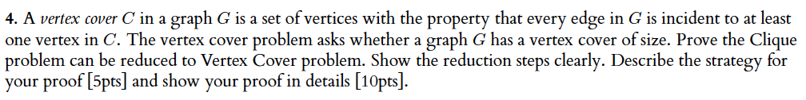

Sources:

Textbook Ch 11.3 #9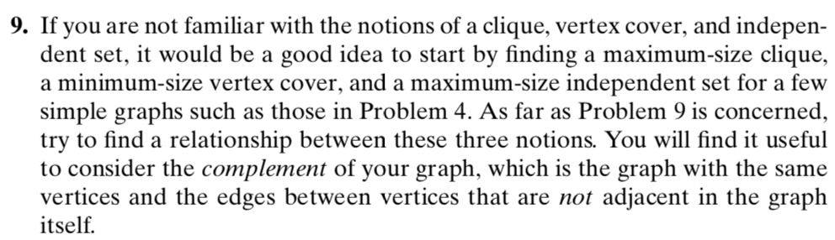

<https://www.youtube.com/watch?v=RD7Oaw0H-W4>

<https://en.wikipedia.org/wiki/Vertex_cover>

<https://www.youtube.com/watch?v=lHCGlcR9VEc>

<http://www.cs.toronto.edu/~ekzhu/teaching/csc373summer2015/tut9.pdf>

<http://www.cs.princeton.edu/~wayne/cs423/lectures/reductions-poly-4up.pdf>

<https://www.youtube.com/watch?v=_dF0FrBLMzM>

General Solution:

1. Given a graph G = (V,E) and integer k
2. Make the complement of G= (v, complement E)
3. Make clique of ((G Compliment), |V|- k)
   1. If you are able to create this it is true if not false

Maximum Clique Problem (NP Complete)

Given a graph G and number K, is there a clique of size K in G?

K=4

G=

G =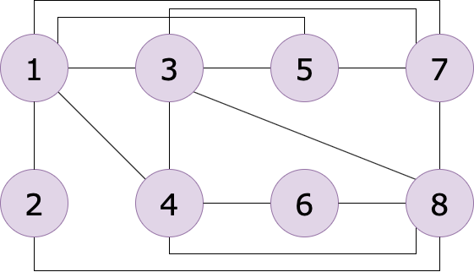

Solution Steps:

1. Check that the degree of each node is K-1, which is 3 in this case
   1. Get rid of 2 (connected to 1 and 8) and 6 (connected to 4 and 8)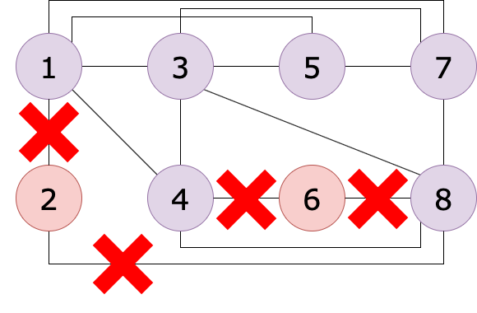
      1. which results in

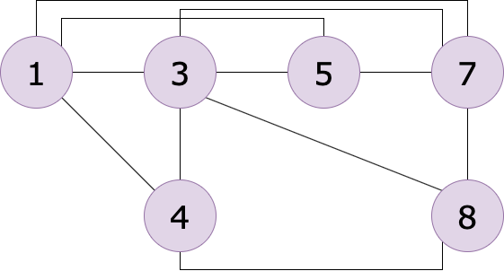

1. Once everyone has a degree of 3, look at each of them individually to see if its neighbors are connected
   1. we check node 4 (neighbors are 1, 3, 8)
      1. We check if they are all each other’s neighbors
         1. 1 and 3 are
         2. 3 and 8 are
         3. 1 and 8 are NOT
            1. 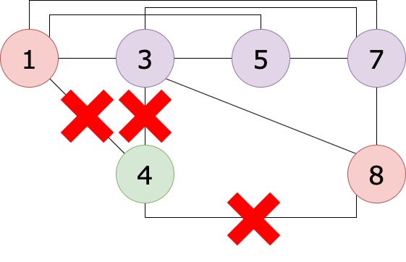

This results in…

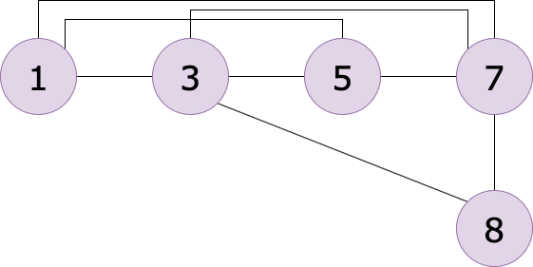

* 1. we check node 8 (neighbors are 3,7)
     1. Only 2 so we remove it

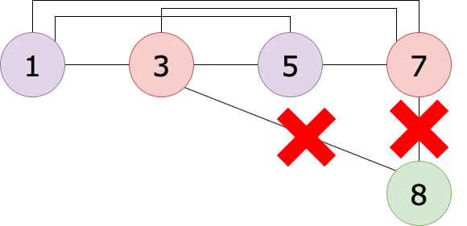

This results in…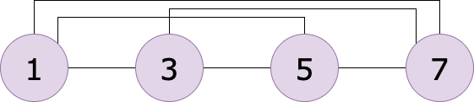

* 1. Now we check that everything is connected to each other
     1. 1 is connected to 3, 5, 7
     2. 3 is connected to 5, 7
     3. 5 is connected to 7
     4. Therefore 1+3+5+7= 16 for our final answer

Minimum Vertex Cover (NP Complete)

Find the minimum number of vertices that will include ALL of the edges!

Example 1

Problem: Solution: 2 (any of these 2 for this specific example)

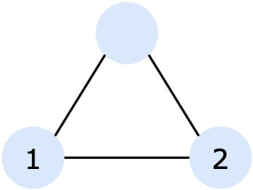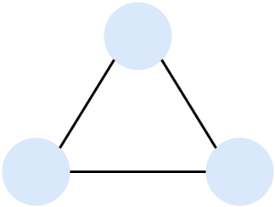

Example 2

Problem: Solution: 3 (either of the bottom nodes for 3 in this specific ex)

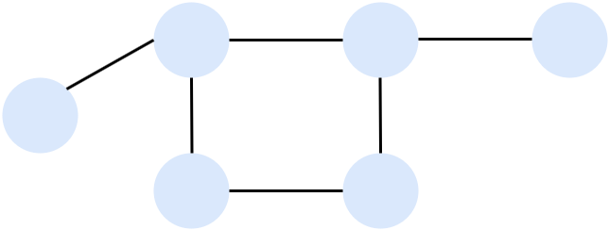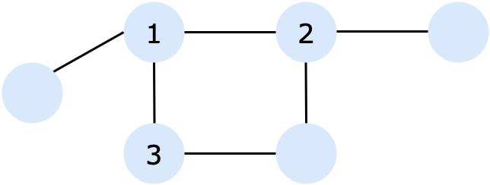

Example 3

Problem: Solution: 4 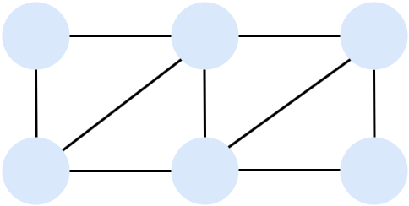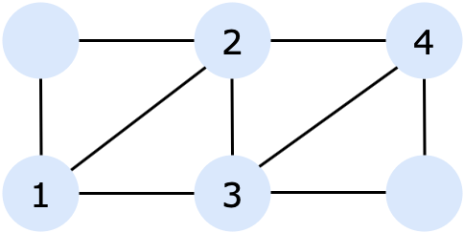

**Prove that a Vertex Cover can be reduced to a Clique**

DEFINITION G has a clique of size k if and only if G’ has a vertex cover of size |V|-k

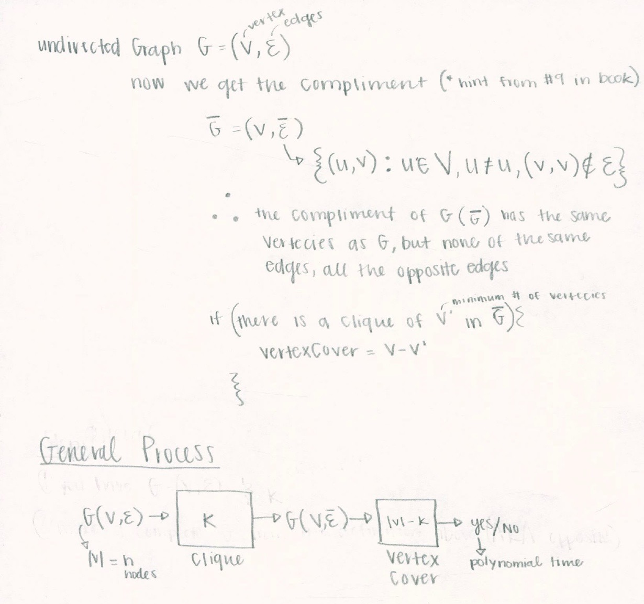

Steps:

1. You have undirected graph G=(V,E) & int K

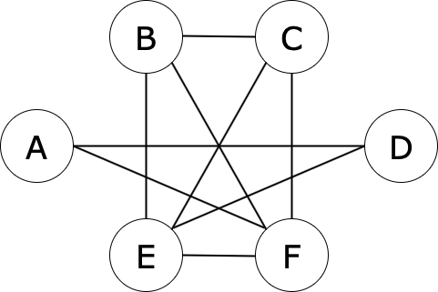

1. Get the Clique (S) of this graph with |S|= k
   1. S = {B,C,E,F}
   2. k = 4

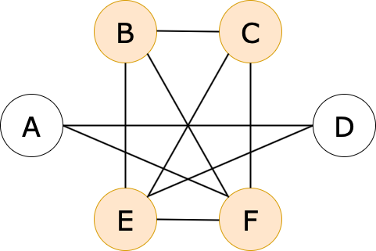

1. Make S’ = V-S (compliment)
   1. S’ = {A,D}

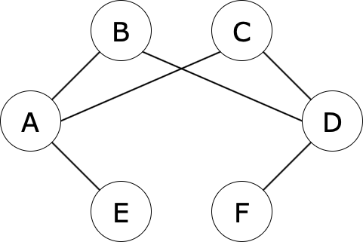

1. To show S’ is a Vertex Cover= V-S={A,D}
   1. Consider any edge (c,d) ∈ E'
      1. Then (c,d) ∉ E
      2. At least one of c or d is not in S (since S forms a clique)
      3. At least one of c or d is in S’
      4. therefore (c, d) is covered by S’

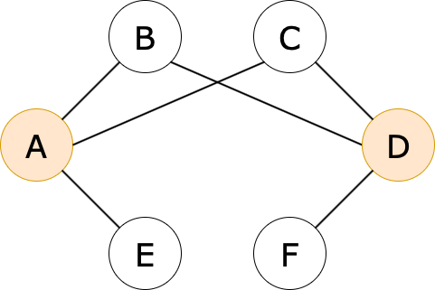

Prove it backwards

1. Make G’



1. Get the Vertex Cover (S’) of this graph
   1. |S’| = |V| - k



1. Consider S= V-S’
   1. Therefore |S| = k
2. Show that S is a clique



* 1. Consider any edge (c,d) ∈ E'
     1. if (c,d) ∈ E', then either c ∈ S' or d ∈ S' or both
     2. By the contrapositive rule, if c ∉ S' and d ∉ S', then they are both in E proving S is a Clique in G

